

**Data analytics report**



July 17, 2024

Contents

Summary 1

Description 1

Conclusion 4

**Figures of table**

Figure 1 : GJ$/year by source on SPACE HEATING (current) 2

Figure 2: GJ $ /year on all 26 houses saved 2

Figure 3: Sum of GJ/year on house number 15 (most) 3

Figure 4:Sum of GJ/year on house number 20 (least) 3

**List of Tables**

Table 1:Total sum of GJ $/year on all 26 houses 2

Table 2: Filtering the top five house number, according to sum GJ $ /year 4

# Summary

This project is based on various energy sources listed accordingly to its house numbers. Describes data in excel using forms which incorporates POWER BI. Power BI is equipped to design charts, reports and the exact composition of the required information.

# Description

The money spent on spacing heating currently is **$2,240.70** per year. This report describes the information on SPACE HEATING systems located in various houses by GJ $/year source as well as house number. Cards are in comparison to charts that creates a current idea of what numbers are displayed.

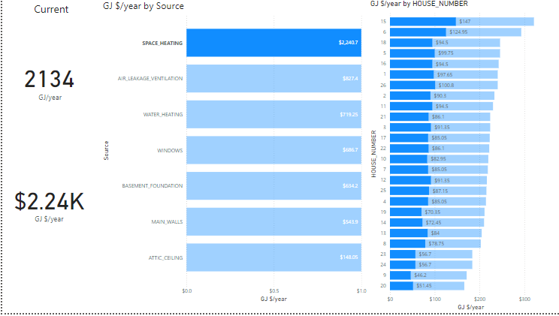

Figure 1 : GJ$/year by source on SPACE HEATING (current)

If all **26 houses** got new furnaces the money saved per year would be **$2,626.05** on furnaces per yearbut, the card shows the rounded version of GJ $ /year.

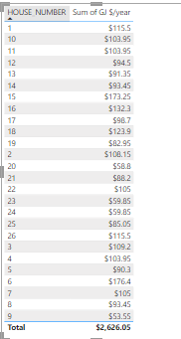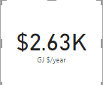

Table 1:Total sum of GJ $/year on all 26 houses

Figure 2: GJ $ /year on all 26 houses saved

The most energy currently used in **house number** **15** denotes that the sum of GJ/ year, ranks accordingly to descending order

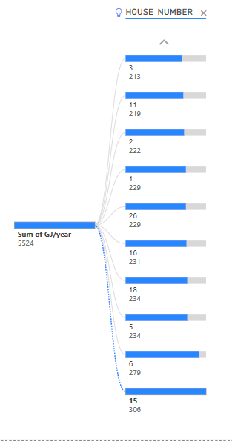

Figure 3: Sum of GJ/year on house number 15 (most)

The least energy which currently used in **house number 20** denotes the sum of GJ/ year as **158**

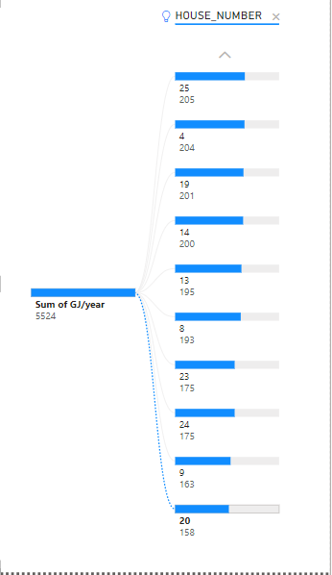

Figure 4:Sum of GJ/year on house number 20 (least)

This table illustrates that five houses which saved the most money if installed new furnaces are

**House number 9,20,23,24 and 19**

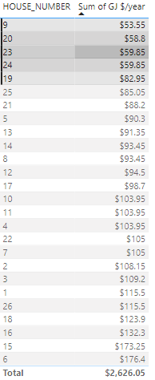

Table 2: Filtering the top five house number, according to sum GJ $ /year

# Conclusion

This report prescribes the following information on Energuide Data which corresponds to House numbers based on Sum of GJ $/year.